**Description:**

* A Health and Fitness platform/website that will provide all services to keep you fit and healthy. The platform will provide users with various fitness training programs, live workout sessions and activities from certified trainers as well as nutrition workshops. It will also provide diet consultations from the best certified Nutritionists and also live consultation for the Physicians.It will track various activities of the user to provide it with the best health solutions.

**Goals:**

* To design and develop a website for health and fitness services.
* To make better and regular communication with consultants regarding users health conditions.
* To provide healthy solutions to users regarding exercise, diet and other activities

**Scope:**

* Target Audience of this website will be 18 to 60 years old.
* Live support or chats with consultants.
* Strong technical platform to provide fitness services

**Competitor Analysis:**

| **Applications** | **Healthify me** | **Cult.fit** | **Fittr** |
| --- | --- | --- | --- |
| Functionality | HealthifyMe is an Indian digital health and wellness platform that provides services such as calorie tracking, one-on-one nutrition, Home workout, fitness coaching, and Diet plans.  Developed for both Android and iOS platforms, the app takes a holistic lifestyle tracking approach to keep users engaged and motivated. | Cult.fit is a health and fitness company offering digital and offline experiences across fitness, nutrition, and mental well-being.The app offers live workout sessions, online dietician consultations, home lab tests, online therapy, and more. | Fittr is the world’s largest online fitness and nutrition community. Fittr started its journey as a small WhatsApp group that used to train a few people and help them get fit.  Today, it is one of the most informative and engaging fitness communities with more than 850,000 members. |
| Features | Connects to applications such as Google Fit, Samsung Health, Fitbit and Garmin , it keeps you fit on all devices!  "Chat with us" feature enables us to communicate with the experts regarding the services anytime.  Studio: Users with premium subscriptions get to choose from a team of in-house certified nutritionists, fitness trainers and yoga coaches.  HealthifySense: Therapy sections for Mental wellness, Personalised guidance.  VaccinateMe: Helps to book slot for COVISHIELD, COVAXIN and SPUTNIK V vaccination | care.fit  Making health easy and accessible  Book online doctor consultations and schedule  diagnostic tests at home.  mind.fit  Mind and Body fitness  Experience mindfulness with our guided yoga,  meditation & therapy sessions.  cult.fit  Makes fitness fun and easy  Try our fun group classes at our cult centers or  work out at best-in-class gyms  eat.fit  Online food ordering option  maintain your diet with proper and healthy meals. | Fittr App serves as a one-stop solution for all health & fitness guidance-related needs. Offering a freemium model, Fittr provides free access to the diet & training tools, all of its features and access to a community of fitness experts & enthusiasts.  Users can get personalised guidance, customised plans & weekly check ups through one of Fittr’s 200+ certified coaches by paying a small premium. |
| Ux Focus | HealthifyMe provides free trial  Calorie tracking | 7 Days Free Trial  Dance Fitness, Yoga, Football, Boxing, Strength & Conditioning, HRX, Prowl, and more.  Home training sessions with our fitness videos to do it yourself. | A body fat calculator  A calorie counter  BMR calculator  Goal setting  Fitness coaching |
| Findings | HealthifyMe provides weight loss diet plans and personal trainers.  Users can chat with an actual nutritionist and a health coach in order to get the most out of their wellness goals.  HealthifyMe is among the world's most trusted health and fitness apps  Lots of notifications and scheduled calls.  With feature Snap, you can use it to photo-track the calories of what you’re about to eat.  The app doesn’t always recognise items correctly.  Provides hand wash tracker, Water intake tracker, sleep tracker, workout tracker, weight loss tracker & calorie tracker | Cult offer group workouts ranging from yoga to Boxing  You keep an eye on the number of healthy activities, including sleep, walking steps, cult/mind.fit classes, Eat.fit.  You can sync Google Fit, Apple Health.  Provides the healthy diet | Fittr provides free access to the diet & training tools, all of its features and access to a community of fitness experts & enthusiasts.  One of the most trusted apps  Provides users with a BMR tracker and a body fat calculator.  Helps the users to set healthy goals  Backed by experts delivering results that are quantifiable & measurable  They co-create solutions that work for you |
| Customers | 16 Millions | 1.5 Millions | 8 Millions |
| Employee | 1175 | 1000 | 399 |
| Target Customer | Age 20-45 | Age group 20-40  Urban Population  Higher income group segment | Age 18-35 |
| No of Installs | 1 Cr+ | 1 Cr+ | 10L+ |
| Competitor Type | Direct Competitor | Direct Competitor | Direct Competitor |
| Personal Opinion | HealthifyMe provides a holistic lifestyle tracking approach to keep users engaged and motivated. | Compatible with other platform such as googlefit, apple health as well when used as an app | Fittr provides free access to the diet & training tools, all of its features and access to a community of fitness experts & enthusiasts because of which users will feel free to try any plan and can attract more users |

Persona 1:

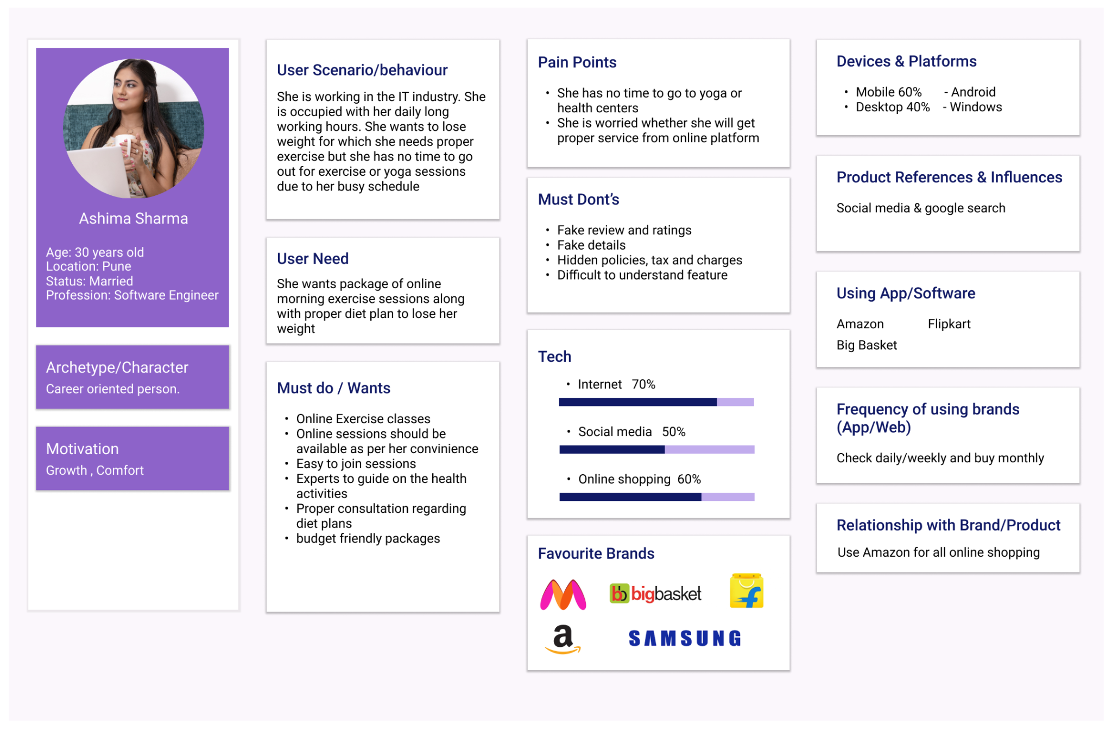

Persona 2:

